**Hópverkefni 2**

**SQL DDL Commands Due Date: 28-02-2018**

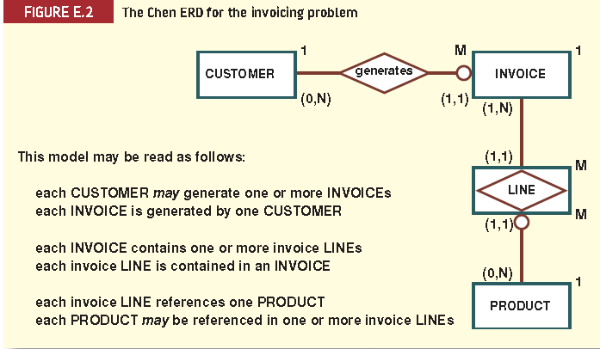

**Attributes**

Customer(CUS_CODE, CUS_LNAME, CUS_FNAME, CUS_INITIAL, CUS_AREACODE, CUS_PHONE, CUS_BALANCE)

Invoice(INV_NUMBER, CUS_CODE, INV_DATE)

Line(LIN_NUMBER, LINE_UNITS, LINE_PRICE)

Product(PROD_CODE, PROD_DESCRIPT, PROD_PRICE, PROD_ON_HAND)

Verdor(VEND_CODE, VEND_CONTACT, VEND_AREACODE, VEND_PHONE)

**1- Creating database and tables:**

Create database called SaleCo, and create the database tables with their corresponding attributes.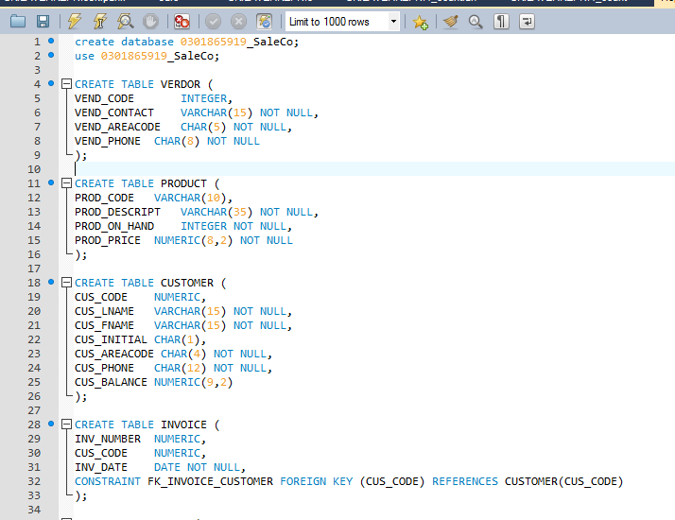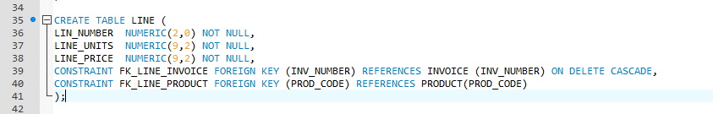

**Note** that the vendor table does not exist in the ER diagram, so you need to figure out what relationship could link it to one of the tables.

**2- primary and foreign keys constraints:**

Add primary and foreign keys constraints to all tables, based on the relationships shown in ER diagram and the following business rules.

- If a row in the invoice table is deleted, the rows that references it in line table also need to be deleted automatically.

-If a row in the customer table is updated, the rows that references it in the invoice table are also updated automatically.

-If row in the product table is updated the rows that references it in line table, are to be set to null value.

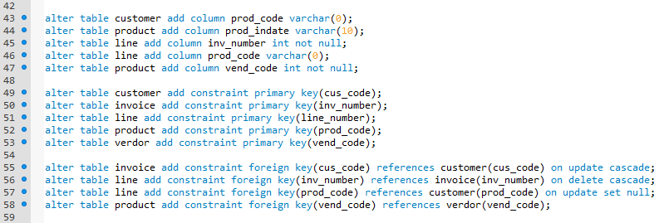

**3- Adding the default values:**

Set the CUS_BALANCE to DEFAULT to 0.00 in customer table.

Set the CUS_AREACODE DEFAULT to '0181' in customer table.

set the LINE_UNITS DEFAULT value to 0.00 in line table

set the LINE_PRICE DEFAULT values to 0.00 in line table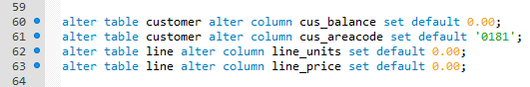

**5-Creating indexes:**

Create an index called CUS_CODEX on (CUS_CODE) in the invoice table

create an index (INV_NUMBER), (P-CODE) in line table

create an index on P_INDATE, called P_INDATEX in product table

create composite index called VENPRODX on V_CODE and P_CODE in product table.

Create INDEX called PROD_PRICEX on P_PRICE descendent order in product table.

delete the PROD_PRICEX index from PRODUCT table.

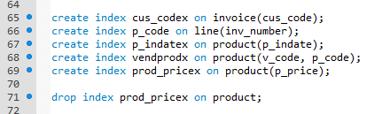

**6- Inserting data in to tables**

Insert the following data into the tables

**CUSTOMER rows**

(10010,'Ramas','Alfred','A','0181','844-2573',0)

(10011,'Dunne','Leona','K','0161','894-1238',0)

(10012,'Smith','Kathy','W','0181','894-2285',345.86)

**INVOICE rows**

(1001,10014,'2008-01-16')

(1002,10011,'2008-01-16')

(1003,10012,'2008-01-16')

**LINE rows**

(1001,1,'13-Q2/P2',1,14.99)

(1001,2,'23109-HB',1,9.95)

(1002,1,'54778-2T',2,4.99)

**PRODUCT rows**

('11QER/31','Power painter, 15 psi., 3-nozzle','2007-11-07’,8, 5,109.99,0.00,25595)

('13-Q2/P2','7.25-cm. pwr. saw blade’,'2007-12-14', 32, 15, 14.99,0.05,21344)

('14-Q1/L3','9.00-cm. pwr. saw blade','2007-11-13', 18, 12, 17.49,0.00,21344)

**VENDOR rows**

(21225,'Bryson, Inc.','Smithson','0181','223-3234','UK','Y')

(21226,'SuperLoo, Inc.','Flushing','0113','215-8995','SA','N')

(21231,'D\&E Supply','Singh','0181','228-3245','UK','Y')

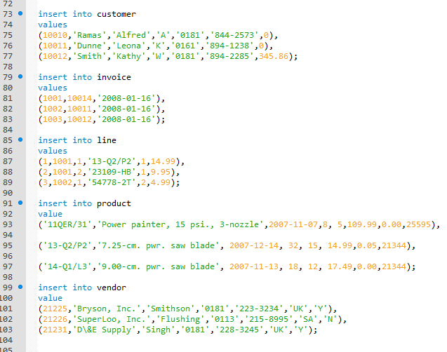

**7- find a solution to the Problem**

The saleCo company wants to keep records of sales employees, so they can identify each employee, his customers and products that he/she sells. Employees are identified by the following attributes.

(EMP_NUM(INT), EMP_TITLE (CHAR (10)), EMP_LNAME(VARCHAR(15)), EMP_FNAME(VARCHAR(15)), EMP_INITIAL(CHAR(1)), EMP_DOB(DATETIME), EMP_HIR_DATE(DATETIME), EMP_AREACODE(CHAR(5)), EMP_PHONE(CHAR(8)), EMP_MGR(INT))

Create the table employee and modify the related tables and their constraints based on the business rules?

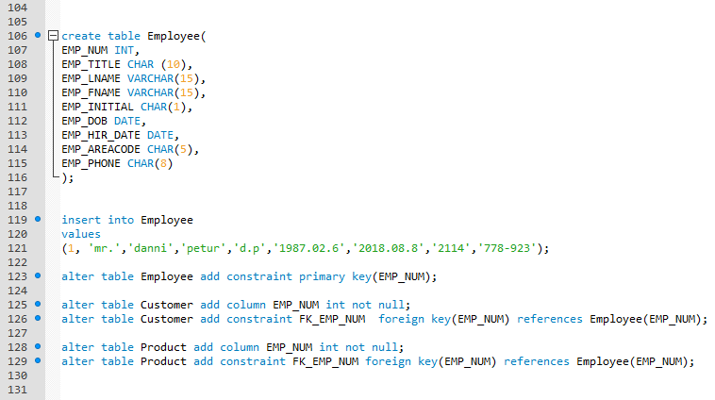

**Note:** upload the assignment as word or pdf file, including the SQL statements.

Abdel